大立光 beta2.09

友達 beta 1

台灣大 beta 0.2

元大50反1 BETA -1.01

大立光(MA2)  
Call:

arima(x = diffdata1, order = c(0, 0, 2))

Coefficients:

ma1 ma2 intercept

-1.1269 0.1269 -0.0003

s.e. 0.0287 0.0285 0.0002

sigma^2 estimated as 7.864: log likelihood = -3007.5, aic = 6023

> Box.test(m1$residuals,lag = 12 ,type = 'Ljung')

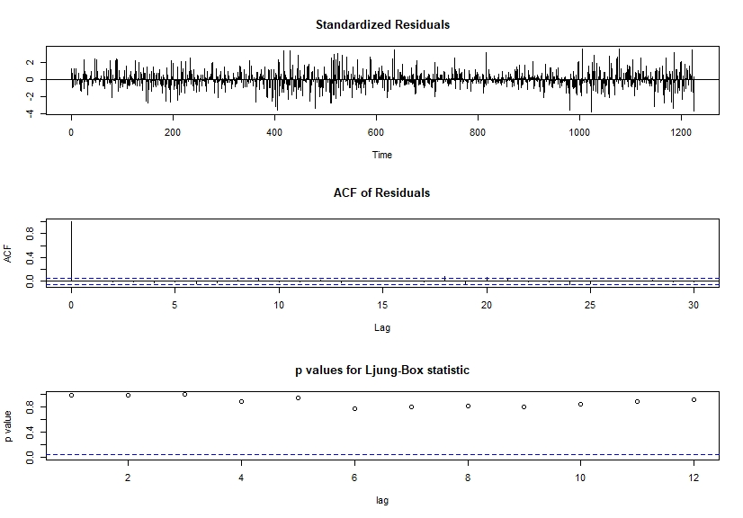

友達2409(ARIMA303)

Call:

arima(x = diffdata1, order = c(3, 0, 3), fixed = c(NA, NA, 0, NA, NA, NA, 0))

Coefficients:

ar1 ar2 ar3 ma1 ma2 ma3 intercept

-0.1716 -0.7817 0 -0.9143 0.7112 -0.7969 0

s.e. 0.1323 0.0766 0 0.1320 0.1358 0.0648 0

sigma^2 estimated as 4.052: log likelihood = -2600.94, aic = 5213.88

> Box.test(m1$residuals,lag = 12 ,type = 'Ljung')

Box-Ljung test

data: m1$residuals

X-squared = 4.6506, df = 12, p-value = 0.9686

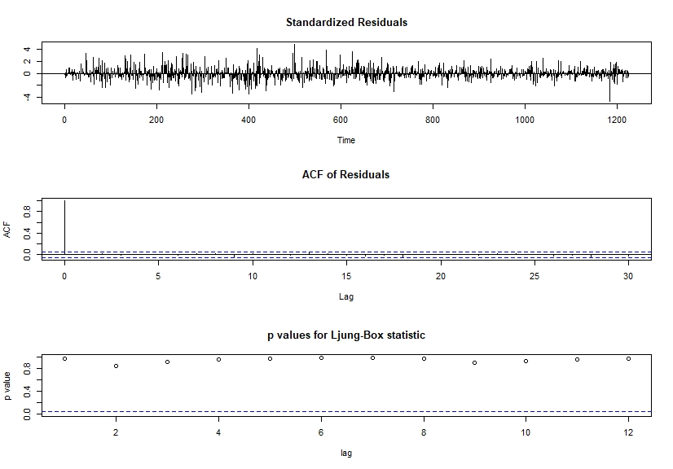

台灣大(ARIMA12.0.12)

Call:

arima(x = diffdata1, order = c(12, 0, 12))

Coefficients:

ar1 ar2 ar3 ar4 ar5 ar6 ar7 ar8 ar9 ar10 ar11 ar12

-0.2737 0.3037 0.1014 0.0716 0.0181 0.4130 -0.3371 -0.4834 -0.2376 -0.1789 0.3919 -0.0621

s.e. 0.2497 0.1822 0.3577 0.1939 0.2080 0.1328 0.2045 0.2695 0.3372 0.2219 0.2076 0.0473

ma1 ma2 ma3 ma4 ma5 ma6 ma7 ma8 ma9 ma10 ma11 ma12

-0.8863 -0.4883 0.2896 -0.0425 0.1134 -0.3694 0.8093 0.0476 -0.3433 0.0106 -0.6013 0.4606

s.e. 0.2503 0.3301 0.3799 0.4186 0.2958 0.2962 0.1685 0.4488 0.2600 0.4774 0.2373 0.1980

intercept

0.0000

s.e. 0.0001

sigma^2 estimated as 0.7639: log likelihood = -1579.3, aic = 3210.59

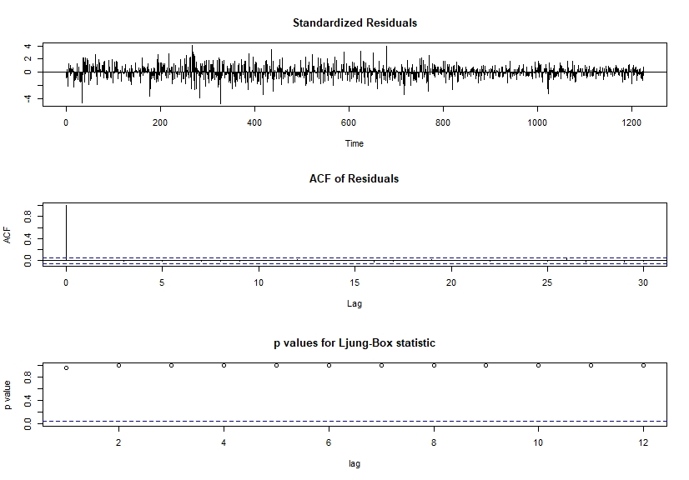

元大50反1 BETA (ARIMA10.0.8)

Call:

arima(x = diffdata1, order = c(10, 0, 8))

Coefficients:

Warning in sqrt(diag(x$var.coef)) : NaNs produced

ar1 ar2 ar3 ar4 ar5 ar6 ar7 ar8 ar9 ar10 ma1 ma2 ma3

-0.4974 0.1749 0.4182 -0.4503 -0.4928 0.1368 0.8774 0.0792 0.0092 -0.0926 -0.521 -0.6866 -0.1443

sigma^2 estimated as 0.7489: log likelihood = -1288.7, aic = 2617.4

> Box.test(m1$residuals,lag = 12 ,type = 'Ljung')

Box-Ljung test

data: m1$residuals

X-squared = 1.3386, df = 12, p-value = 0.9999

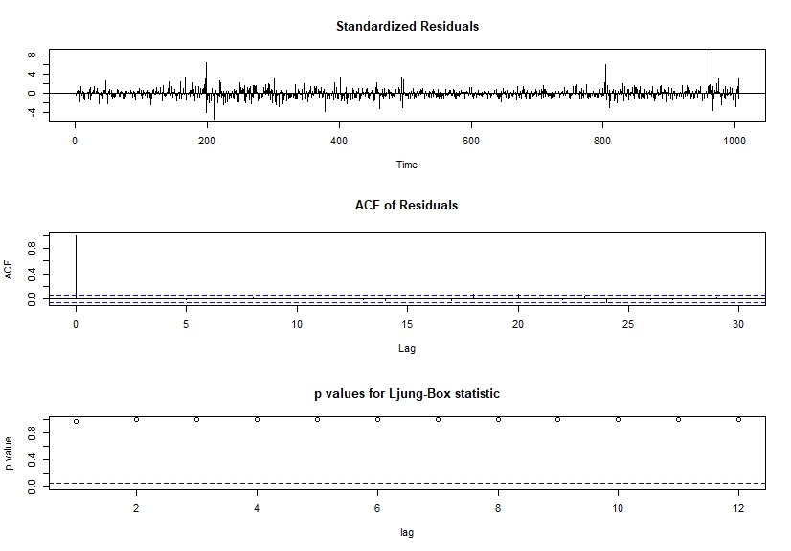

Hi everyone im XXX my topic is asset allocation portfolio

So why im interested in this, because in the inverstment course ,we have seen the markowizt’s MPT right?

And its important because baesd on the MPT we can develop other asset pricing model like CAPM or the fama French three factors

And im wondering if I can use MPT and certain time siries model to form a portfolio and beat the market

So how do I plan to do this?

First I look for 4 assets that their beta is closed to 2,1,0,and-1

So I choosed the following 4 stock that Ive heard before

Next I fit the stock’s past 4 year return using ARMA+GARCH

Next I will find the efficient frontier and optimal portfolio using model prediction

I will predict the data using moving window that is : using 4 year historical data to predict 3 month return and form a optimal portfolio and then in the next 3 month we use its 4 year past data to find another portfoilio

And the last I will compare this portfolio to the actual return’s optimal portfolio and the ETF to see if it is more profitable

And this my stock return data , I run the tsdiag and it look like this

And I think I make a mistake is that I need to do the residual test if there is garch effect and then do the tsdiag

So I will go back and check it again